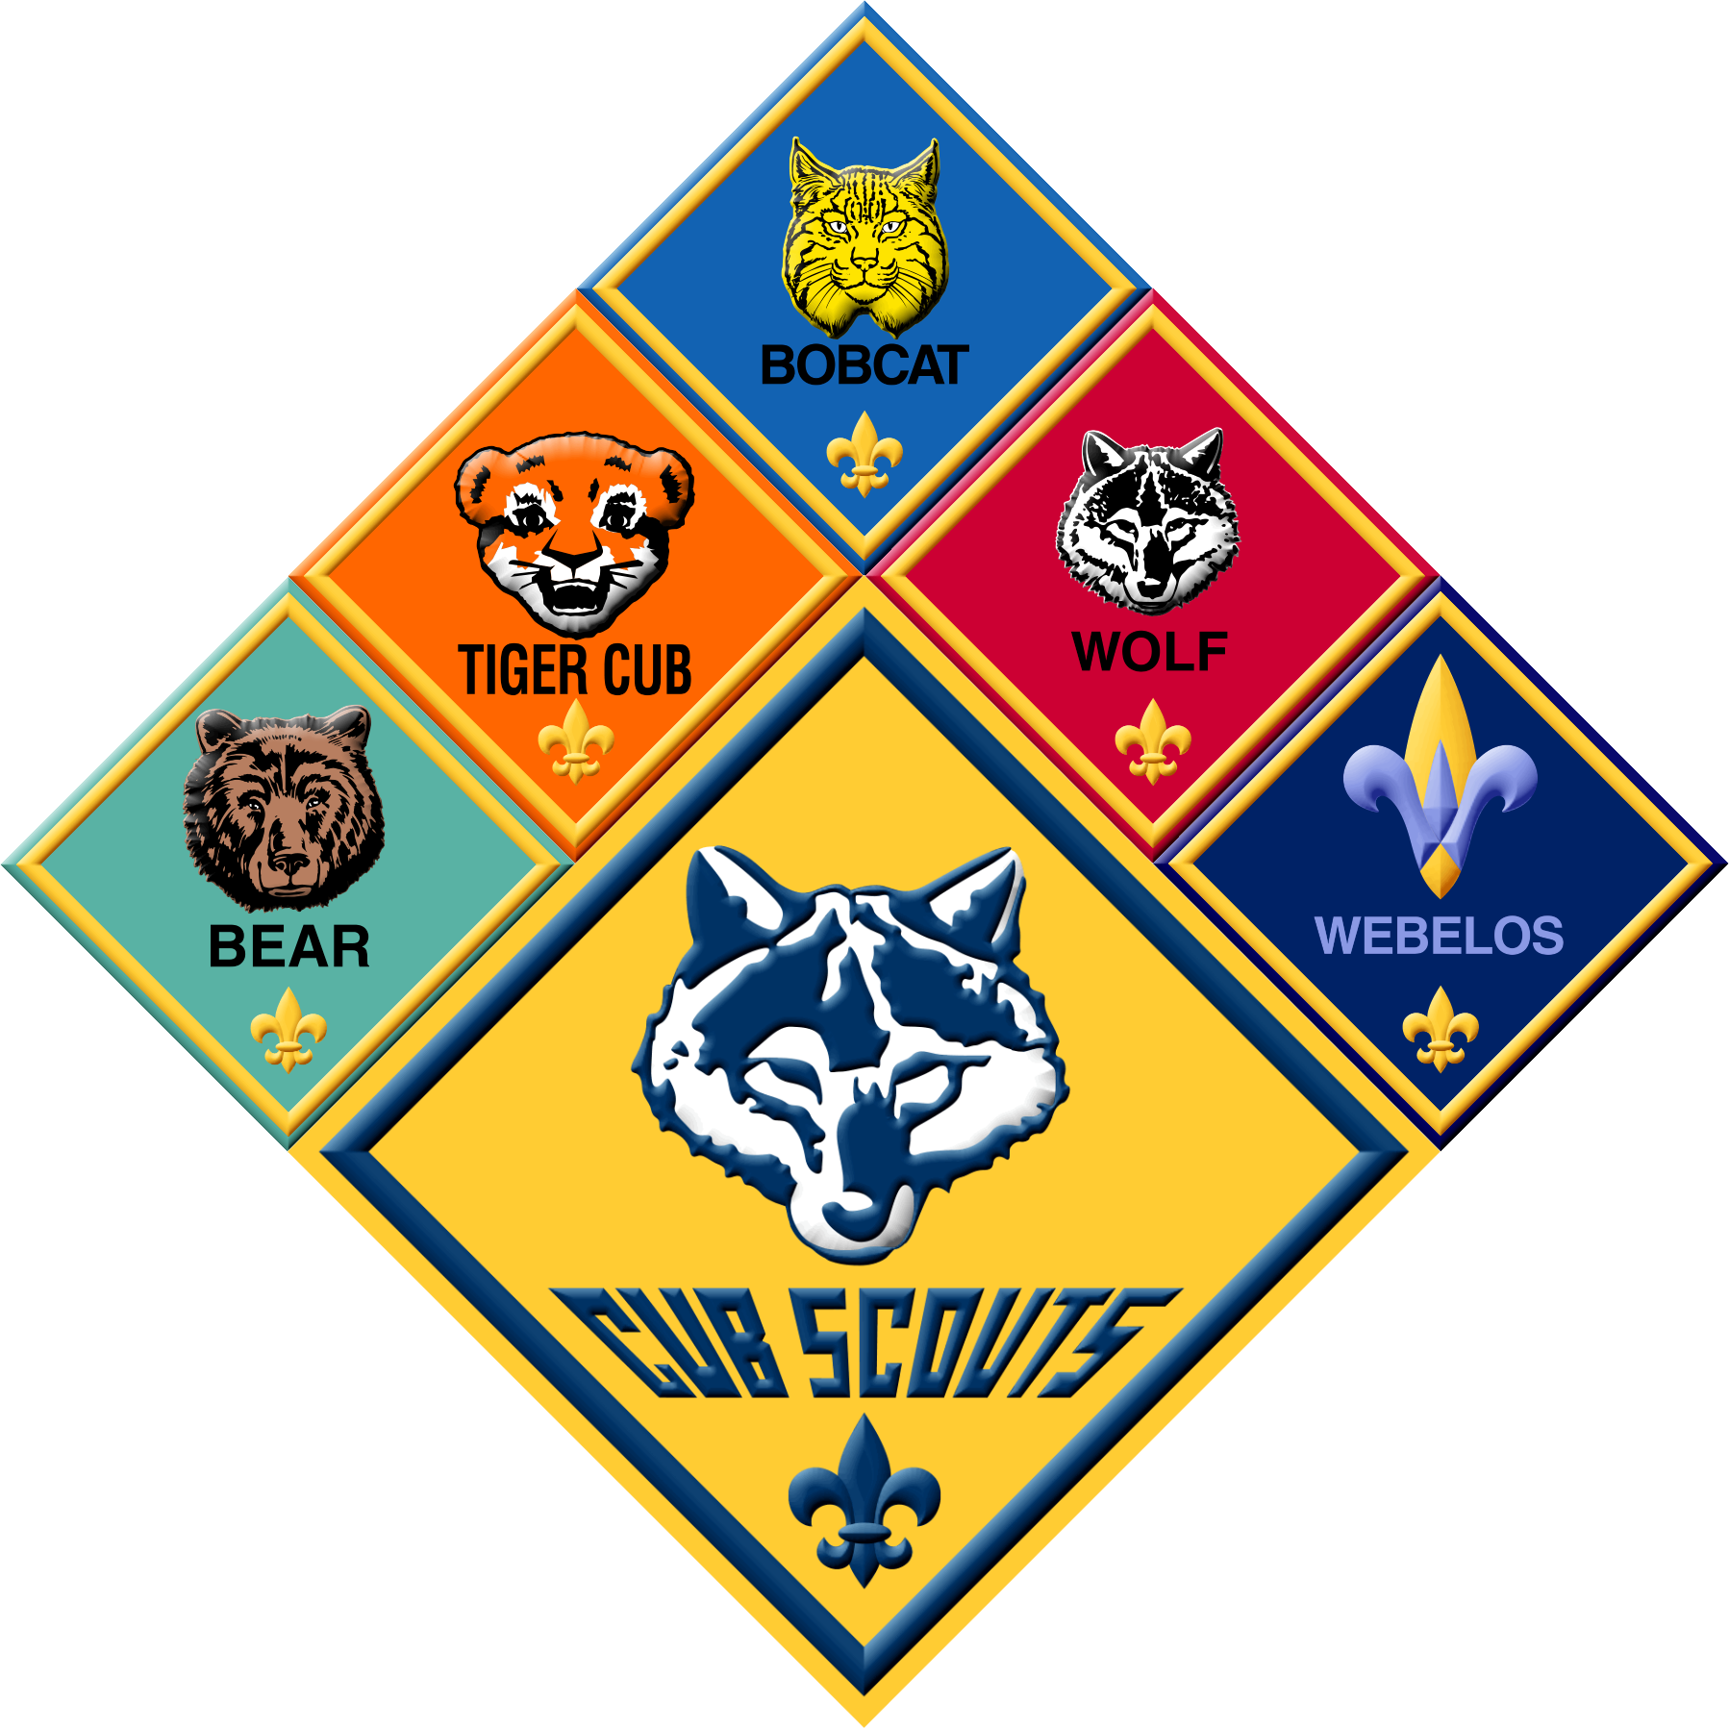

# **Talent Release Form**

I hereby assign and grant to the Boy Scouts of America the right and permission to use and publish the photographs/film/videotapes/electronic representations and/or sound recordings made of me by the Boy Scouts of America, and I hereby release the Boy Scouts of America from any and all liability from such use and publication.

# **PLEASE PRINT CLEARLY**

Name: _______________________________________________________________

Relationship to Child(ren) (if applicable) ____________________________________

Name(s) of Cubscout(s) and any siblings that may participate in Pack activities:

_____________________________________________________________________

Address: _____________________________________________________________

City: ___________________________ State: ____________ Zip: __________

Phone Number: _______________________________________________________

Troop/Pack #: ___Pack 61_______ Troop/Pack City:__Flemington, NJ_________

Signed: ______________________________________________________________

Witness: _____________________________________________________________